**Chatbot Based Online Shopping Web Application**

1 **MANOJ KUMAR,** 2**GAYATRI,** 3**VINEELA,** 4**SHIVA KIRAN,** 5**PRAMODH**

**ABSTRACT:**

The project seeks to introduce a chatbot-driven web application as a means to enhance the online shopping experience, compensating for the absence of the personal touch found in physical stores. By harnessing artificial intelligence, this chatbot can adeptly comprehend the user's natural language queries and preferences, consequently offering personalized product recommendations and shopping guidance. Additionally, the chatbot incorporates machine learning to analyze user behavior and feedback, thereby refining its performance and recommendations over time. Key features of the application encompass:

An intuitive and user-friendly interface, facilitating both text and voice-based interactions with the chatbot.

A 24/7 customer service offering prompt responses to common queries, product information dissemination, and issue resolution.

A personalized shopping assistant, enabling users to discover products that align with their specific needs, style, and budget.A robust and compliant data management system, meticulously safeguarding user privacy and data security.

A machine learning model that adapts and improves based on user interactions and feedback, while concurrently providing insights for enhanced user engagement and satisfaction.

The primary objective of this project is to develop a forward-thinking web application that bridges the divide between online and offline shopping, thereby furnishing a more gratifying, efficient, and secure online shopping environment. The chosen programming language for this endeavor is Python, accompanied by a range of natural language processing and machine learning libraries and frameworks. Additionally, a dataset comprising product information and customer reviews will be employed to train and validate the chatbot. This project serves as an exemplar of chatbot technology's potential in the realm of e-commerce and explores the promising prospects for the future of online commerce.

**INTRODUCTION:**

The ongoing technological advancements within the rapidly expanding e-commerce industry have ushered in transformative changes in the way we engage with online shopping platforms. One of the most remarkable innovations in this space is the emergence of chatbot-based online shopping web applications, which have significantly redefined the customer experience. These intelligent virtual assistants have breathed new life into the world of digital commerce, ushering in convenience, personalization, and unprecedented efficiency in an age characterized by rapid digital transformation. The integration of chatbots into the sphere of online marketing holds the promise of reshaping the marketing landscape.

At the core of contemporary commerce lies personalization, and chatbots excel in delivering tailored shopping experiences. Leveraging machine learning and data analytics, these bots can comprehend user preferences, purchase histories, and browsing behaviors, enabling them to provide product recommendations customized to individual interests and requirements. What sets chatbot-based online shopping web applications apart is their round-the-clock availability. Unlike human customer service representatives, chatbots stand ready to assist customers, regardless of the time.

Moreover, these chatbots exhibit remarkable flexibility, as they can seamlessly integrate with various messaging platforms such as WhatsApp, Facebook Messenger, or be directly embedded into e-commerce websites. This adaptability ensures that customers can engage with brands through interactive channels in the manner they prefer.

Chatbots play a crucial role in streamlining inventory management and order processing by offering real-time updates on stock levels, assisting in order tracking, and providing information about shipping and product delivery without the need for human intervention. As technology advances, chatbots are continually enhancing their natural language processing capabilities, enabling them to comprehend and address complex customer queries, thereby elevating the overall quality of customer service.

Data security and privacy stand out as major concerns in the realm of online shopping, and chatbots are expressly designed to address these issues. They are proficient at securely handling sensitive customer information, including payment details, to ensure a safe and secure shopping environment. Moreover, chatbots are highly scalable, capable of managing a substantial volume of customer inquiries simultaneously. This guarantees that no customer is left waiting, even during peak shopping seasons or promotional events.

The amalgamation of technology and convenience has given rise to chatbot-based online shopping web applications, reshaping the way consumers shop and interact with digital storefronts. These intelligent virtual assistants have become integral components of contemporary online retail, delivering a multitude of advantages that elevate the shopping experience. In the era of swift digital transformation, the integration of chatbots into online shopping platforms serves as a testament to the potent force of innovation in meeting the ever-increasing expectations of tech-savvy consumers.

In summary, chatbot-based online shopping web applications represent a significant leap forward in the world of e-commerce. Their ability to furnish personalized, efficient, and engaging shopping experiences positions chatbots to redefine how consumers interact with online stores and fortify the connection between brands and their customers. As businesses increasingly embrace this transformative technology, online shopping is poised to become even more convenient and enjoyable for consumers worldwide.

**LITERATURE SURVEY:**

**Development of Multilingual Chatbots Using AIML in Indian Languages**

This paper explores the challenges and potential of developing chatbots in Indian languages with the use of AIML (Artificial Intelligence Markup Language). It delves into the intricacies of creating multilingual chatbots and the opportunities they present**. - Author: Nabeela Khatoon**

**Design and Implementation of an AIML-Based Customer Service Chatbot**

The paper presents the design and implementation of a customer service chatbot using AIML. It provides insights into how AIML can be integrated with Natural Language Processing (NLP) techniques to enhance the performance of chatbots in customer service scenarios**. - Author: Kavya N**

**Comparative Analysis of AIML and ChatScript for Chatbot Development**

This paper offers a technical overview of two widely used open-source languages, AIML and ChatScript, for building chatbots. It compares these languages based on factors such as ease of implementation, access to external resources, knowledge acquisition, integration with customized ontologies, and suitability for mobile applications. The study concludes that there's no one-size-fits-all approach, and developers must make technology choices based on their specific requirements.  **- Author: Sasa Arsovski**

**Enhancing Vietnamese Chatbot Performance with Rasa NLU**

This paper presents a method for improving chatbot performance using a custom Rasa NLU pipeline, with a focus on non-English languages like Vietnamese. The study showcases the superiority of a custom component, cpFastText, over TensorFlow-based and mBERT models in intent classification and entity extraction. It also discusses the use of this chatbot in a question-answering system based on the BERT model.  **- Author: Maxim Shcherbakov**

**Standardized Architecture for Conversational Agents (Chatbots)**

This paper proposes a standardized architecture for chatbot solutions, highlighting critical components necessary for effective implementation. The suggested architecture promises to enhance user experiences, provide multi-channel capabilities, integrate services, and position organizations at the forefront of innovation and technology in the chatbot space.

**- Author: Roshan Khan**

**Customizable Multilingual Chatbot System for Customer Support**

The paper introduces a customizable, multilingual chatbot system designed for organizations to create their customer service chatbots. It integrates live chat and ticketing systems, allowing agents to offer real-time assistance and generate support tickets for more complex issues. The study acknowledges certain limitations and outlines areas for potential improvement, emphasizing the importance of deploying multilingual chatbots, supporting speech-to-text and text-to-speech, enhancing language models, and implementing deep learning algorithms**. - Author: Vinothini Kasinathan**

**METHODOLOGY:**

Developing a customized chatbot that bridges the gap between online and offline shopping while integrating Natural Language Processing (NLP) techniques is a systematic endeavor. It commences with the identification of user pain points through thorough research and proceeds to the precise definition of the chatbot's objectives. The selection of an appropriate architecture, whether rule-based, machine learning-based, or a hybrid model, is pivotal to enable the effective integration of NLP. The process includes the acquisition and preparation of labeled datasets, facilitating the recognition of user intents and the extraction of Named Entities (NER), such as product names and user-specific details. The development phase involves creating an intuitive interface to facilitate text and voice interactions while ensuring real-time access to product information. Personalization and recommendation features are implemented to enhance the user experience, alongside robust data security measures. Rigorous testing, user evaluation, and continuous learning mechanisms are employed to refine the chatbot's functionality. Ensuring 24/7 availability caters to users outside standard business hours, and potential integration with offline stores is explored. The incorporation of user support features, coupled with a well-planned marketing strategy, is integral to a successful launch. Continuous monitoring, analytics, and future improvements contribute to the chatbot's ongoing enhancement, with a feedback loop from users providing valuable insights. Ultimately, this methodology results in a custom chatbot that delivers a seamless, secure, and personalized shopping experience, leveraging NLP for user intent recognition and information extraction.

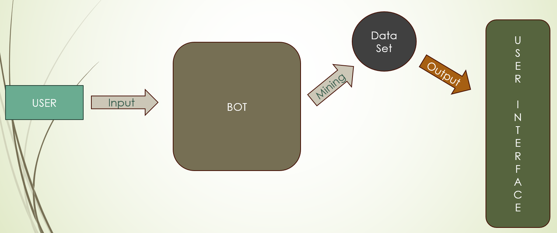

**DATA SET:**

The acquisition of a substantial dataset comprising comprehensive information about various products and their detailed features represents a valuable resource for businesses and researchers alike. Such a dataset offers the foundation for a multitude of applications, from improving product recommendations and market analysis to enhancing customer experiences. By harnessing this data, businesses can refine their understanding of product specifications and customer preferences, thereby facilitating more informed decision-making. Researchers can employ this dataset to gain insights into consumer behavior and preferences, ultimately contributing to the development of more effective marketing strategies and product design. The wealth of information within this dataset provides a unique opportunity to unravel trends, uncover patterns, and extract valuable knowledge that can drive innovation, customer satisfaction, and business success. In an era marked by data-driven insights, a comprehensive product dataset emerges as a potent tool with far-reaching implications for both the business world and academia.

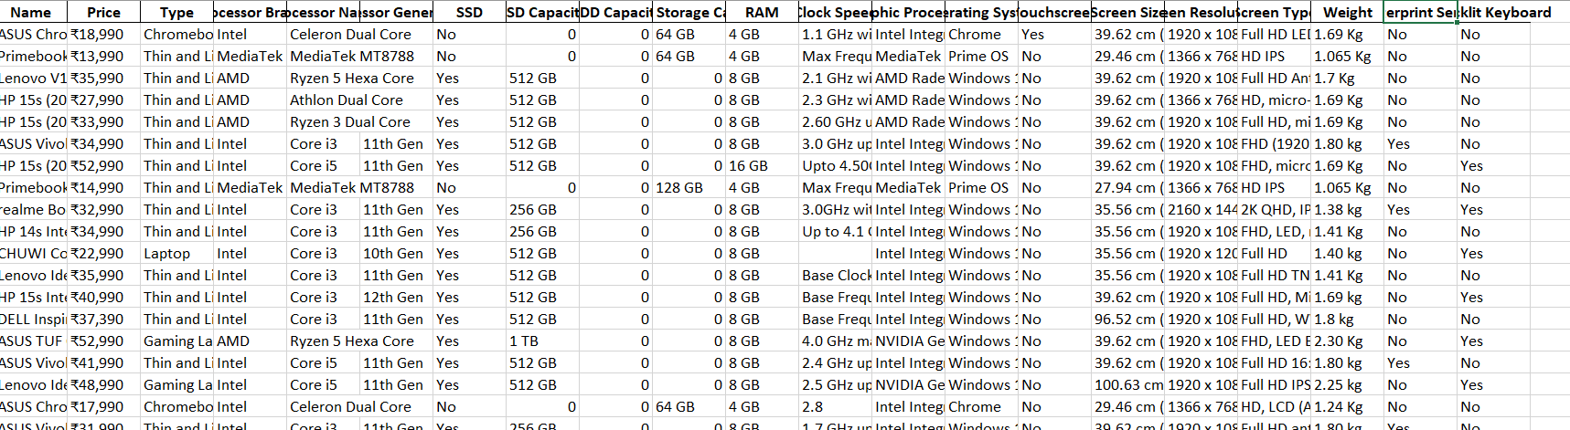

**Image1**



**Image 2**

**Natural Language Processing (NLP):**

**Intent Recognition:**

In the realm of chatbots, Natural Language Processing (NLP) techniques, particularly Intent Recognition, play a pivotal role in comprehending and responding to user inputs. Intent Recognition involves the use of algorithms, often implemented with machine learning classifiers, to discern the underlying intent behind a user's message or query. This is essential because it empowers the chatbot to recognize whether the user is seeking information, asking a question, expressing a desire to make a purchase, or engaging in any other type of interaction. By accurately identifying the user's intent, the chatbot can then craft an appropriate response, whether it involves providing product recommendations, addressing a query, or guiding the user through the purchase process. This capability not only enables the chatbot to understand the user's needs but also streamlines the conversation, making it more efficient and user-friendly. Intent Recognition, therefore, forms the foundation of effective and context-aware interactions between users and chatbots, enhancing the overall user experience in online shopping or any other domain where chatbots are deployed.

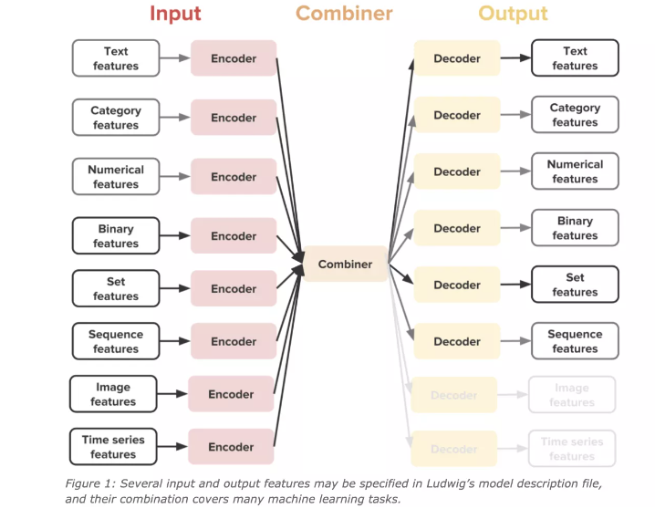

**Named Entity Recognition (NER):**

Named Entity Recognition (NER) plays a crucial role in Natural Language Processing (NLP), enabling chatbots to identify and extract specific entities from user input. These entities can include product names, categories, personal details, or locations. By incorporating NER, chatbots can distinguish and separate these relevant pieces of information from the user's messages, enabling them to provide tailored and accurate responses.

This improvement greatly enhances user interactions, whether it involves offering personalized product recommendations or managing orders, ultimately leading to a more satisfying user experience, regardless of the chatbot's application, whether in e-commerce or any other domain.

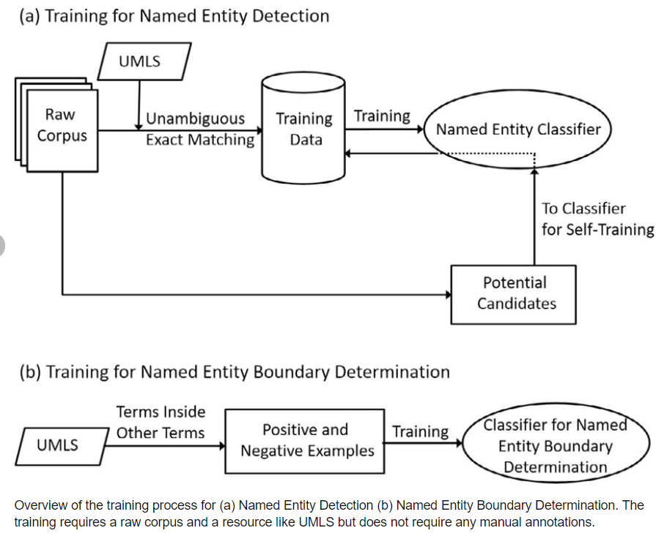

**MODEL IMPLEMENTATION:**

In our project methodology, we have leveraged the capabilities of Natural Language Processing (NLP), specifically focusing on Intent Recognition and Named Entity Recognition (NER), to build a chatbot that significantly enhances the customer's purchasing experience.

Our methodology begins with the implementation of NLP techniques, including Intent Recognition. We utilize algorithms like Intent Classification, often driven by machine learning classifiers. This enables our chatbot to delve deep into the user's interactions and comprehend their specific intent. We can distinguish whether a user is making an inquiry, seeking detailed product information, or expressing an interest in making a purchase.

Additionally, our methodology employs Named Entity Recognition (NER) algorithms. NER is instrumental in identifying crucial entities within user messages. These entities can include product names, categories, and user-specific details. This facilitates the chatbot's ability to extract essential details during the conversation.

Through the integration of Intent Recognition and NER, our chatbot ensures a highly personalized and efficient service. It tailors its responses based on the user's requirements, providing product information and features that precisely align with their preferences. This level of personalization guarantees that the customer receives a tailored experience, ultimately resulting in a more satisfying purchasing process.

Our project methodology revolves around this innovative NLP approach to create a chatbot that is not only responsive to user needs but also capable of providing an enriched and highly individualized shopping experience, ultimately benefiting both the customer and the business.

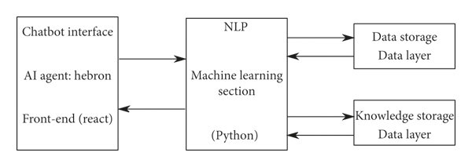

**RESULT AND ANALYSIS :**

Analyzing the results and performance of a chatbot-based web application involves evaluating various aspects of the system, including user engagement, conversion rates, customer satisfaction, and the effectiveness of the chatbot itself. . Here is a summary of the results and analysis.

**User Management:**

Measure the number of users who interact with the chatbot versus those who don't. Analyze the length and depth of interactions (eg, number of messages exchanged, time spent in conversation). Check the frequency of return visits of users who have used the chatbot.

**Customer Satisfaction:**

Collect remarks via post-interaction surveys or critiques to gauge consumer pleasure.

Assess consumer remarks and ratings to perceive regions for development.

Analyze the internet promoter score (NPS) to apprehend how likely users are to advise the utility.

**Chatbot Effectiveness:**

Measure the accuracy of the chatbot's responses to user queries.

Track the range of successful transactions initiated by means of the chatbot.

Assess how nicely the chatbot handles commonplace user inquiries and resolves problems.

**Cost Savings:**

Analyze the reduction in customer support fees due to the chatbot's ability to deal with common queries.

Compare the value of retaining and improving the chatbot with the savings generated by using reducing guide workforce.

**User Retention:**

Evaluate whether the chatbot contributes to user retention and engagement over time.

Measure the impact of personalized recommendations and offers generated by the chatbot.

**Feedback and Improvement:**

Continuously collect user feedback to identify areas for improvement in the chatbot's functionality.

Use user feedback to enhance the chatbot's capabilities and responsiveness.

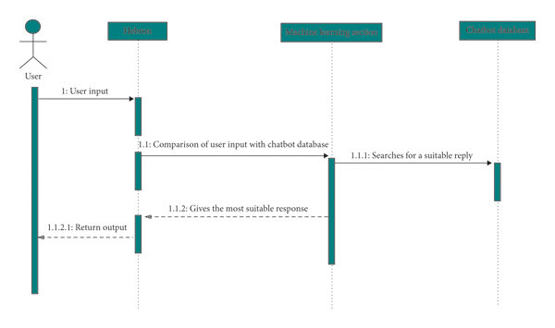

**CONCLUSION:**

In Conclusion , a chatbot-based online shopping web application has the potential to revolutionize the e-commerce experience. To succeed, it must engage users effectively, drive conversions, maintain customer satisfaction, and continually improve through data-driven decisions and optimizations. The application's technical performance and data security are also essential to building trust and long-term success in the online shopping market.

Our project provides an online shopping platform for everyone so that they can design dresses as per their choice and requirement.

Our project provides an interface between customers and the fashion stylist.

Customers can chat with chatbot and can check for available products.

**REFERENCES :**

1] J. Weizenbaum, “ELIZA—a computer program for the study of natural language communication between man and machine,” Commun. ACM, vol. 9, no. 1, pp. 36–45, 1966.

2] L. Lin, L. F. D’Haro, and R. E. Banchs, “A web-based platform for collection of human-chatbot interactions,” HAI 2016 - Proc. 4th Int. Conf. Hum. Agent Interact., pp. 363–366, 2016.

3] N. Mhatre, K. Motani, M. Shah, and S. Mali, “Donna Interactive Chat-bot acting as a Personal Assistant,” Int. J. Comput. Appl., vol. 140, no. 10, pp. 6–11, 2016.

4] A. Pradana, “Intelligent Conversational Bot for Interactive Marketing with Consumer-centric Approach,” Int. J. Comput. Inf. Syst. Ind. Manag. Appl., vol. 6, pp. 265–275, 2017.

5] M. S. Satu, M. H. Parvez, and Shamim-Al-Mamun, “Review of integrated applications with AIML based chatbot,” 1st Int. Conf. Comput. Inf. Eng. ICCIE 2015, pp. 87–90, 2016.

6] S. Gupta, D. Borkar, C. De Mello, and S. Patil, “An E-Commerce Website based Chatbot,” Int. J. Comput. Sci. Inf. Technol., vol. 6, no. 2, pp. 1483–1485, 2015.

7] de Oliveira, Juan Carlos, Danilo Henrique Santos, and Mário Popolin Neto. "Chatting with Arduino platform through Telegram Bot." In 2016 IEEE International Symposium on Consumer Electronics (ISCE), pp. 131-132. IEEE, 2016.

8] Pricilla, Catherine, Dessi Puji Lestari, and Dody Dharma. "Designing Interaction for Chatbot-Based Conversational Commerce with User-Centered Design." In 2018 5th International Conference on Advanced Informatics: Concept Theory and Applications (ICAICTA), pp. 244-249. IEEE, 2018.

9] Jia, J. The Study of the Application of a Keywords-based Chatbot System on the Teaching of Foreign Languages. arXiv 2003, arXiv:cs/0310018.

10] Sojasingarayar, A. Seq2Seq AI Chatbot with Attention Mechanism. M.A. Thesis, Department of Artificial Intelligence, IA School/University-GEMA Group, France, 2020.

11]. Bala, K.; Kumar, M.; Hulawale, S.; Pandita, S. Chat-Bot For College Management System Using A.I. Int. Res. J. Eng. Technol. (IRJET) 2017, 4, 4.

12]. Ayanouz, S.; Abdelhakim, B.A.; Benhmed, M. A Smart Chatbot Architecture based NLP and Machine Learning for Health Care Assistance. In Proceedings of the 3rd International Conference on Networking, Information Systems & Security, Marrakech, Morocco, 31 March–2 April 2020; pp. 1–6, doi:10.1145/3386723.3387897.

13]. Kumar, R.; Ali, M.M. A Review on Chatbot Design and Implementation Techniques. Int. J. Eng. Technol. 2020, 7, 11.

14] Cahn, J. CHATBOT: Architecture, Design, & Development. Ph.D. Thesis, University of Pennsylvania, School of Engineering and Applied Science 2017.

15]Okuda, T.; Shoda, S. AI-based Chatbot Service for Financial Industry. FUJITSU Sci. Tech. J. 2018, 54, 5.

16]. Brandtzaeg, P.B.; Følstad, A. Why People Use Chatbots. In Internet Science; Kompatsiaris, I., Cave, J., Satsiou, A., Carle, G., Passani, A., Kontopoulos, E., Diplaris, S., McMillan, D., Eds.; Lecture Notes in Computer Science; Springer International Publishing: Berlin/Heidelberg, Germany, 2017; Volume 10673, pp. 377–392.

17] Costa, P. Conversing with personal digital assistants: On gender and artificial intelligence. J. Sci. Technol. Arts 2018, 59–72, doi:10.7559/CITARJ.V10I3.563.

18] Fernandes, A. NLP, NLU, NLG and How Chatbots Work. 2018. Available online: https://chatbotslife.com/nlp-nlu-nlg-and-howchatbots-work-dd7861dfc9df (accessed on: 19/05/2021).